**Decision Tree – Predictice Modeling Comparison**

**Decision Tree – All attributes:**

The decision tree algorithm was applied to the training and test datasets using all available attributes. The performance of the model was evaluated based on key metrics such as accuracy, sensitivity (recall), specificity, precision, and the F-measure. These metrics provide insights into the model's effectiveness in classifying instances correctly.

Training Set Results:

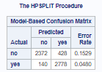

**Confusion Matrix Output:**

True Negatives (TN): 2,372

* The model correctly predicted 'no' for 2,372 instances.

False Positives (FP): 428

* The model incorrectly predicted 'yes' for 428 instances where the actual response was 'no'.

False Negatives (FN): 140

* The model incorrectly predicted 'no' for 140 instances where the actual response was 'yes'.

True Positives (TP): 2,778

* The model correctly predicted 'yes' for 2,778 instances.

**Performance Metrics:**

Accuracy: 90.05%

* The model was able to accurately predict whether a given instance belonged to the 'yes' or 'no' class 90.05% of the time.
* (2372 + 2778) / 5718 = 0.9005

Sensitivity (Recall/TPR): 95.20%

* Shows that 95.20% of actual 'yes' instances were correctly identified by the model.
* 2778 / (140 + 2778) = 0.9520

Specificity (TNR): 84.71%

* Indicates that 84.71% of actual 'no' instances were correctly identified by the model.
* 2372 / (2372 + 428) = 0.8471

Precision: 86.64%

* Reflects that 86.64% of the instances predicted as 'yes' were actually 'yes'.
* 2778 / (428 + 2778) = 0.8664

F-Measure: 90.74%

* Represents the harmonic mean of precision and recall, indicating a balanced performance.
* 2 * ((0.8664 * 0.9520) / (0.8664 + 0.9520)) = 0.9074

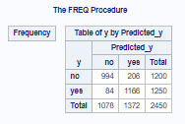Test Set:

**Confusion Matrix Output:**

True Negatives (TN): 994

* The model correctly predicted 'no' for 994 instances.

False Positives (FP): 206

* The model incorrectly predicted 'yes' for 206 instances where the actual response was 'no'.

False Negatives (FN): 84

* The model incorrectly predicted 'no' for 84 instances where the actual response was 'yes'.

True Positives (TP): 1,166

* The model correctly predicted 'yes' for 1,166 instances.

**Performance Metrics:**

Accuracy: 88.16%

* The model was able to accurately predict whether a given instance belonged to the 'yes' or 'no' class 88.16% of the time.
* (994 + 1166) / 2450 = 0.8816

Sensitivity (Recall/TPR): 93.28%

* Shows that 93.28% of actual 'yes' instances were correctly identified by the model.
* 1166 / (84 + 1166) = 0.9328

Specificity (TNR): 82.83%

* Indicates that 82.83% of actual 'no' instances were correctly identified by the model.
* 994 / (994 + 206) = 0.8283

Precision: 84.98%

* Reflects that 84.98% of the instances predicted as 'yes' were actually 'yes'.
* 1166 / (206 + 1166) = 0.8498

F-Measure: 88.94%

* Represents the harmonic mean of precision and recall, indicating a balanced performance.
* 2 * ((0.8498 * 0.9328) / (0.8498 + 0.9328)) = 0.8894

**Overall Takeaway from Decision Tree Model (All Attributes)**

The decision tree model trained using all attributes demonstrates strong performance in both the training and test sets. With an accuracy of 90.05% on the training set and 88.16% on the test set, the model effectively classifies the majority of instances correctly. The model shows a high sensitivity (recall) on both sets, meaning it is particularly effective at identifying positive instances ('yes'). However, there is a slight drop in specificity and precision from the training to the test set, indicating the model's tendency to produce more false positives on unseen data. While the model performs well, there is room for improvement, particularly in enhancing its generalizability and reducing overfitting.

**Comparison between Training and Test Sets**

* Accuracy: The model performs slightly better on the training set (90.05%) compared to the test set (88.16%), which is expected due to overfitting.
* Sensitivity: The model maintains high sensitivity across both sets, indicating consistent performance in identifying positive instances.
* Specificity: A slight drop from 84.71% (training) to 82.83% (test) suggests the model is less effective at correctly identifying negative instances in the test set.
* Precision: Precision decreases from 86.64% on the training set to 84.98% on the test set, further indicating a slight increase in false positives when the model is applied to new data.

**Decision Tree – Selected attributes:**

The decision tree algorithm was applied to the training and test datasets using a selected subset of attributes. The model's performance was evaluated based on key metrics, including accuracy, sensitivity (recall), specificity, precision, and the F-measure. These metrics help assess the model's effectiveness in classifying instances correctly.

Strategy for Selecting Attributes for the Selected Attributes Model

* Initial Selection Based on Decision Tree Results:
  + Begin by identifying the top 4 attributes from the decision tree results using all attributes. These attributes are the most influential in the model and should be retained.

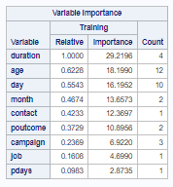

* Evaluate Correlation with Class Attribute:
  + After retaining the top 4 attributes, evaluate the remaining attributes' correlations with the class attribute (y).
    - Duration, age, day, month attributes kept
  + Remove any attribute that showcases a weak correlation with the class attribute unless it exhibits strong correlation with another attribute.
    - Pdays kept (strong correlation with Poutcome)
  + Keep attributes with moderate to strong correlations with the class attribute.
    - Poutcome kept (moderate correlation with class attribute)
    - Job kept (moderate correlation with class attribute)

From this strategy, the following attributes were selected to go into the selected attributes decision tree model:

* y
* poutcome
* pdays
* month
* job
* duration
* age
* day

Training Set Results:

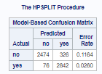

**Confusion Matrix Output:**

True Negatives (TN): 2,474

* The model correctly predicted 'no' for 2,474 instances.

False Positives (FP): 326

* The model incorrectly predicted 'yes' for 326 instances where the actual response was 'no'.

False Negatives (FN): 76

* The model incorrectly predicted 'no' for 76 instances where the actual response was 'yes'.

True Positives (TP): 2,842

* The model correctly predicted 'yes' for 2,842 instances.

**Performance Metrics:**

Accuracy: 92.9%

* The model accurately predicted whether a given instance belonged to the 'yes' or 'no' class 92.9% of the time.
* (2474 + 2842) / 5718 = 0.929

Sensitivity (Recall/TPR): 97.4%

* The model correctly identified 97.4% of actual 'yes' instances.
* 2842 / (76 + 2842) = 0.974

Specificity (TNR): 88.4%

* The model correctly identified 88.4% of actual 'no' instances.
* 2474 / (2474 + 326) = 0.884

Precision: 89.7%

* The model correctly predicted 'yes' for 89.7% of the instances.
* 2842 / (2842 + 326) = 0.897

F-Measure: 93.5%

* The harmonic mean of precision and recall, indicating a balanced performance.
* 2 * ((0.897 * 0.974) / (0.897 + 0.974)) = 0.935

Test Set:

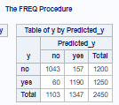

**Confusion Matrix Output:**

True Negatives (TN): 1,043

* The model correctly predicted 'no' for 1,043 instances.

False Positives (FP): 157

* The model incorrectly predicted 'yes' for 157 instances where the actual response was 'no'.

False Negatives (FN): 60

* The model incorrectly predicted 'no' for 60 instances where the actual response was 'yes'.

True Positives (TP): 1,190

* The model correctly predicted 'yes' for 1,190 instances.

**Performance Metrics:**

Accuracy: 91.1%

* The model accurately predicted whether a given instance belonged to the 'yes' or 'no' class 91.1% of the time.
* (1043 + 1190) / 2450 = 0.911

Sensitivity (Recall/TPR): 95.2%

* The model correctly identified 95.2% of actual 'yes' instances.
* 1190 / (1190 + 60) = 0.952

Specificity (TNR): 86.9%

* The model correctly identified 86.9% of actual 'no' instances.
* 1043 / (1043 + 157) = 0.869

Precision: 88.3%

* The model correctly predicted 'yes' for 88.3% of the instances.
* 1190 / (1190 + 157) = 0.883

F-Measure: 91.7%

* The harmonic mean of precision and recall, indicating a balanced performance.
* 2 * ((0.883* 0.952) / (0.883 + 0.952)) = 0.917

**Overall Takeaway from Decision Tree Model (Selected Attributes)**

The decision tree model trained using selected attributes demonstrates excellent performance in both the training and test sets. With an accuracy of 92.9% on the training set and 91.1% on the test set, the model effectively classifies the majority of instances correctly. The model shows high sensitivity (recall) across both sets, meaning it is particularly effective at identifying positive instances ('yes'). While there is a slight drop in specificity and precision from the training to the test set, the model maintains a balanced performance. Nonetheless, there is room for improvement, especially in reducing false positives and enhancing the model's ability to generalize to unseen data.

**Comparison between Training and Test Sets**

* Accuracy: The model performs slightly better on the training set (92.9%) compared to the test set (91.1%), which is a good indication of the model's generalizability.
* Sensitivity: The model maintains high sensitivity across both sets, indicating consistent performance in identifying positive instances.
* Specificity: There is a slight decrease from 88.4% (training) to 86.9% (test), suggesting a minor reduction in the model's ability to correctly identify negative instances in the test set.
* Precision: Precision decreases from 89.7% on the training set to 88.3% on the test set, indicating a small increase in false positives when the model is applied to new data.

**Decision Tree Model Comparison – All attributes vs Selected attributes:**

This section compares the performance of decision tree models using all attributes versus selected attributes. The comparison is based on confusion matrix outputs and performance metrics, visualized in Figure 1 and Figure 2 (in appendix).

The decision tree model using selected attributes demonstrates improved performance over the model using all attributes. The accuracy, sensitivity, and F-measure are higher for the selected attributes model, indicating better overall classification performance. The selected attributes model also shows a reduction in false positives and false negatives in both training and test sets.

Confusion Matrix Improvements:

Training Set:

* True Negatives: Improved by 102 in the selected attributes model (from 2,372 to 2,474), indicating enhanced accuracy in identifying 'no' instances.
* False Positives: Decreased by 102 in the selected attributes model (from 428 to 326), reflecting a reduction in incorrect 'yes' predictions.
* False Negatives: Decreased by 64 in the selected attributes model (from 140 to 76), showing fewer missed 'yes' instances.
* True Positives: Increased by 64 in the selected attributes model (from 2,778 to 2,842), highlighting improved identification of 'yes' instances.

Test Set:

* True Negatives: Improved by 49 in the selected attributes model (from 994 to 1,043), leading to better identification of 'no' instances.
* False Positives: Decreased by 49 in the selected attributes model (from 206 to 157), resulting in fewer incorrect 'yes' predictions.
* False Negatives: Decreased by 24 in the selected attributes model (from 84 to 60), showing fewer missed 'yes' instances.
* True Positives: Increased by 24 in the selected attributes model (from 1,166 to 1,190), reflecting improved correct identification of 'yes' instances.

Performance Metrics Improvements:

Training Set:

* Accuracy: Improved from 90.05% (all attributes) to 92.90% (selected attributes), indicating a more accurate model overall.
* Sensitivity (Recall): Increased from 95.20% (all attributes) to 97.40% (selected attributes), demonstrating the model's enhanced ability to identify true 'yes' instances.
* Specificity: Improved from 84.71% (all attributes) to 88.40% (selected attributes), reflecting better performance in identifying true 'no' instances.
* Precision: Increased from 86.64% (all attributes) to 89.70% (selected attributes), indicating more reliable predictions of 'yes'.
* F-Measure: Rose from 90.74% (all attributes) to 93.50% (selected attributes), showcasing a better balance between precision and recall.

Test Set:

* Accuracy: Improved from 88.16% (all attributes) to 91.10% (selected attributes), indicating better overall performance on new data.
* Sensitivity (Recall): Increased from 93.28% (all attributes) to 95.20% (selected attributes), highlighting improved detection of 'yes' instances.
* Specificity: Improved from 82.83% (all attributes) to 86.90% (selected attributes), showing better identification of 'no' instances.
* Precision: Increased from 84.98% (all attributes) to 88.30% (selected attributes), meaning predictions of 'yes' are more accurate.
* F-Measure: Rose from 88.94% (all attributes) to 91.70% (selected attributes), reflecting an improved balance between precision and recall.

**Overall Takeaway from All vs Selected Attribute Model Comparison**

The selected attributes model demonstrates significant improvements over the all attributes model across both confusion matrix results and performance metrics. The model using selected attributes has shown better classification accuracy, sensitivity, specificity, precision, and F-measure, both in training and test sets. This suggests that selecting the most relevant features has enhanced the model's ability to accurately and effectively classify instances, with reduced misclassifications and better overall performance.

By focusing on the most relevant attributes, the selected attributes model has achieved higher accuracy, indicating that the chosen features are more predictive of the class attribute. The improvements in sensitivity (recall) reflect a greater ability to correctly identify instances where the client has subscribed to a term deposit ("yes"), which is crucial for targeting potential subscribers effectively. Enhanced specificity and precision suggest that the model is now better at distinguishing between clients who have not subscribed ("no") and those who have subscribed, minimizing false positives and negatives.

In summary, the refined feature selection has not only boosted the overall performance metrics but also positively impacted the model's ability to predict whether a client has subscribed to a term deposit, leading to more accurate and reliable predictions.

**Appendix**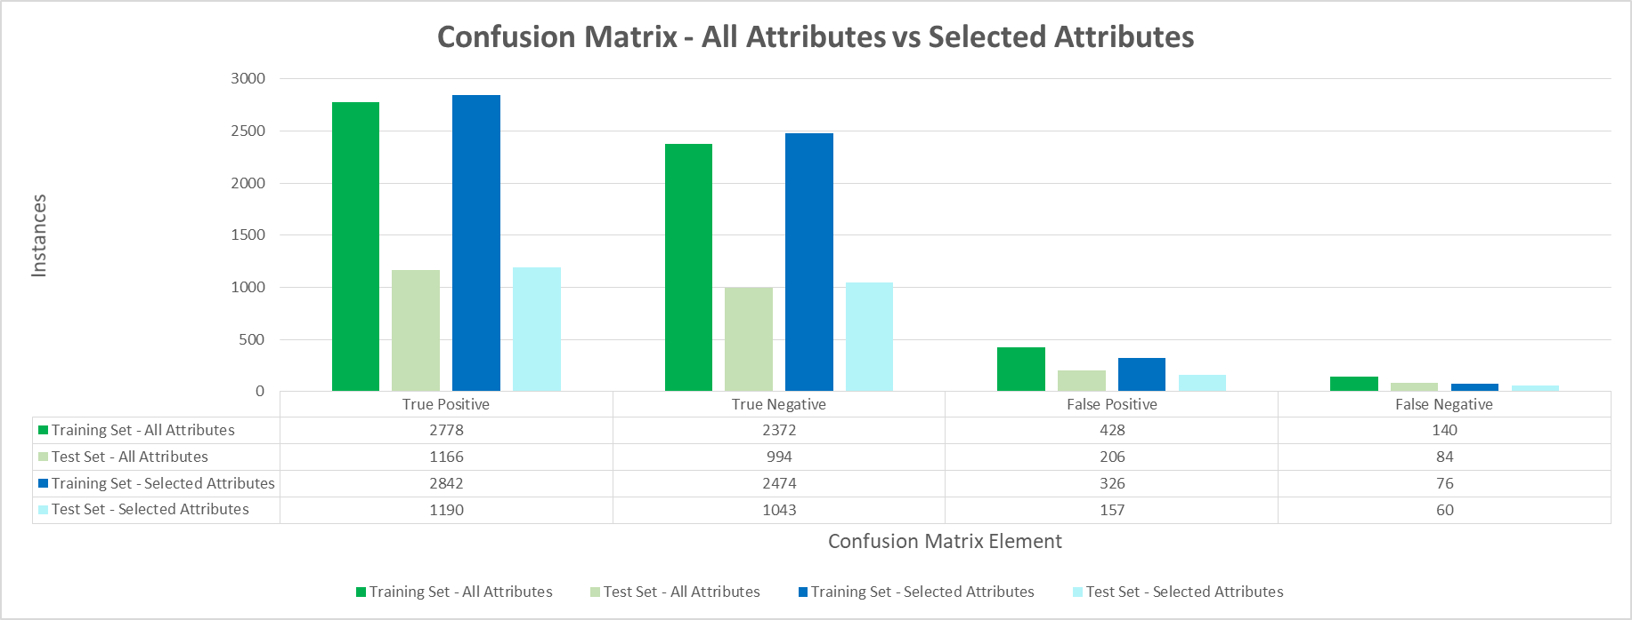

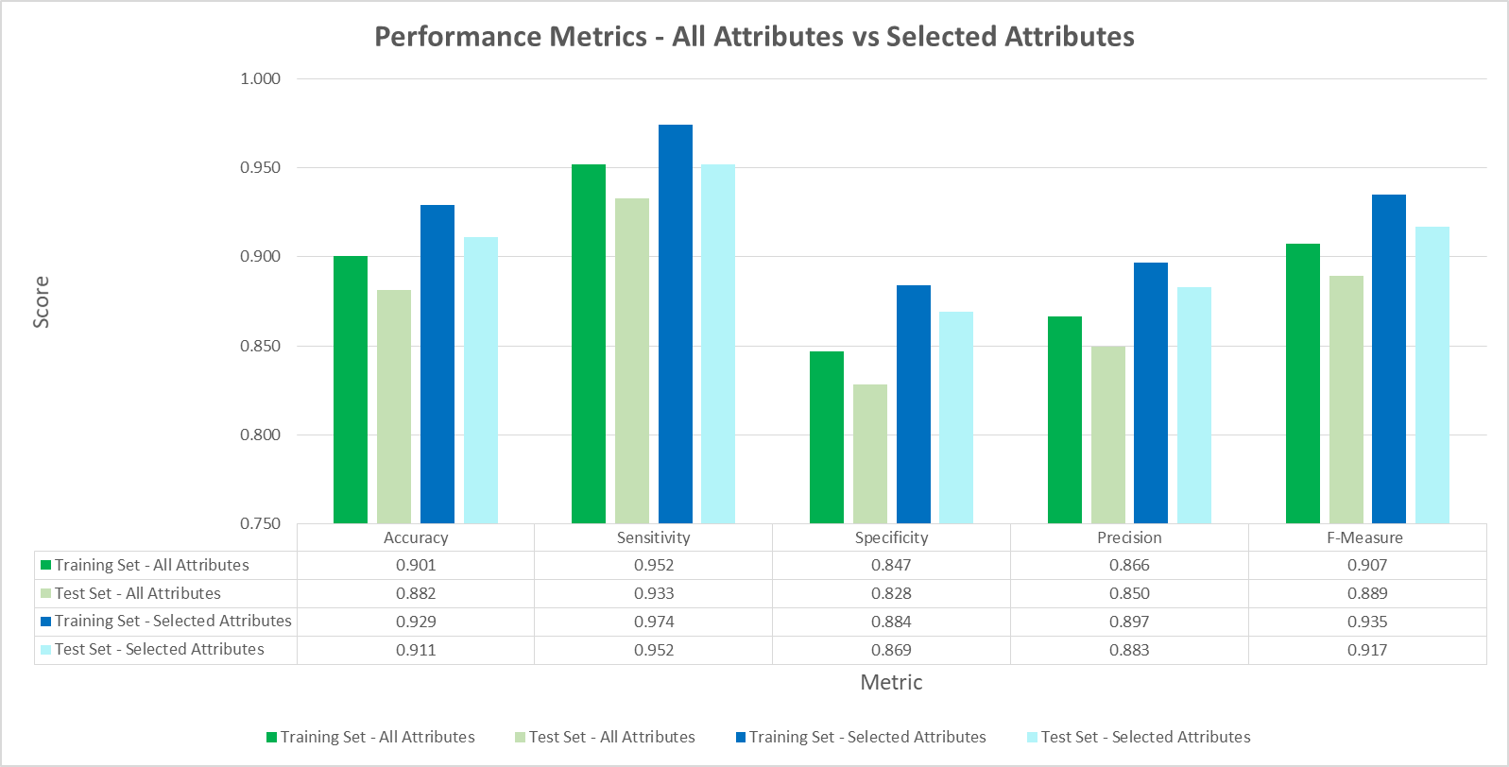*Figure 1: Confusion Matrix – All Attributes vs Selected Attributes*

*Figure 2: Performance Metrics – All Attributes vs Selected Attributes*